Name: ______________________________________________ Period: ___ Date: ____________________

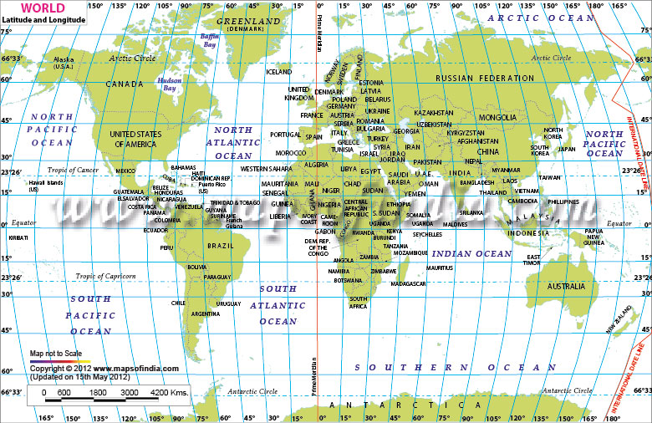

Mark the following cities on the map with a dot. Write the initials of each city next to the dot.

A. Anchorage: 61ºN, 150ºW
B. Beijing: 40ºN, 116ºE
C. Cairo: 30ºN, 31ºE
CH. Chicago: 41ºN, 87ºW
CT. Cape Town: 34ºS, 18ºE
D. Damascus: 35ºN, 36ºE
F. Fargo: 46ºN, 96ºW
HO. Honolulu: 21ºN, 157ºW
H. Hong Kong: 22ºN, 114ºE
J. Jakarta: 6ºS, 106ºE
JE. Jerusalem: 31ºN, 35ºE
KW. Key West: 24ºN, 81ºW
LA. Los Angeles: 34ºN, 118ºW
LI. Lima: 12ºS, 77ºW
LO. London: 51ºN, 0ºW
MC. Mexico City: 19ºN, 99ºW
MO. Moscow: 55ºN, 37ºE
MU. Mumbai: 19ºN, 72ºE
NA. Nairobi: 1ºS, 37ºE
NO. New Orleans: 30ºN, 90ºW
NY. New York: 40ºN, 74ºW
R. Rio de Janeiro: 23ºS, 43ºW
RA. Raleigh: 35ºN, 78ºW
SE. Seattle: 47ºN, 122ºW
SY. Sydney: 34ºS, 151ºE
T. Toronto: 43ºN, 79ºW
TK. Tokyo: 35ºN, 139ºE

Find the coordinates for the following locations.
Location | Latitude | Longitude
Hudson Bay
Iceland
France
Pakistan
Sudan
Madagascar
Peru
New Guinea
Napal

