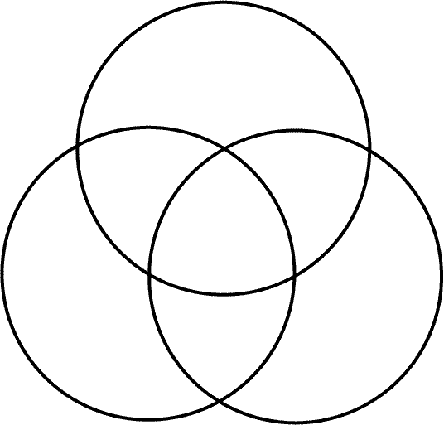
Name: _______________________________________________ Period: ___ Date: _______________ Lava Types Venn Diagram
Pillow Lava
Aa Lava
Pahoehoe Lava

