Name: ______________________________________ Period: ___ Date: __________________
Venn Diagram: Convergent vs Divergent Boundaries
Compare and contrast divergent and convergent plate boundaries. Place the number corresponding to the list of characteristics below in the most suitable locations on the diagram.

- Rocks on either side of boundary are typically of different ages.
- Example: Nazca and South American plate boundary.
- Associated rock deformation and crust destruction
- Magnetic symmetry and isochron maps
- Oceanic lithosphere may be present on both sides of the plate boundary.
- Only young ocean lithosphere present.
- Plates move away from each other.
- Associated with slab pull.
- Shallow earthquakes may occur
- Submarine mountain ranges (ex. Mid-Atlantic Ridge)
- Plates move toward each other.
- Volcanic activity.
- Magma rises to surface at or near the boundary.
- Affected by mantle convection currents.
- Causes continents to divide.
- Associated with rift valleys (ex. East Africa Rift Valley).
- Creation of oceanic crust
- Ring of Fire
- Causes continents to combine.
- Continental mountain formation.
- Associated with ridge push.
- Chains of volcanic islands form (island arcs).
- Continental lithosphere on one side of plate boundary, oceanic lithosphere on the other.
- Associated with mid-oceanic ridges.
- Example: Boundary between Nazca and Pacific plates.
- Deep earthquakes may occur.
- Associated with oceanic trenches.
- Rocks on either side of boundary are the same age.
- Buoyant magma chambers

Convergent Boundaries Divergent Boundaries
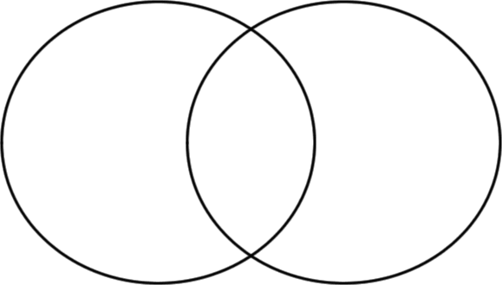
Name:______________________________________________ Period: ___ Date: ________________________
Venn Diagram: Convergent Plate Boundaries
Research the three different types of convergent boundaries to identify their features. Write the features that are unique to each boundary in the corresponding large area of the circles; note features that they share in the overlap areas. Provide examples and draw an illustration of each type of convergent boundary.
Oceanic-Oceanic Oceanic-Continental
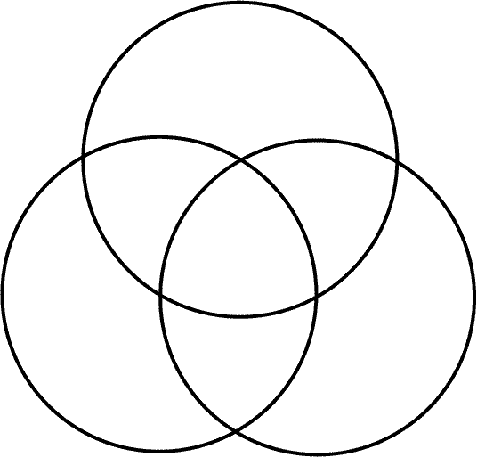
Continental-Continental
Name: _____________________________________________ Period: ___ Date: __________________________
Venn Diagram: Continental Crust vs Oceanic Crust
Research the two types of Earth’s crust to identify their features. Write the features that are unique to each boundary in the corresponding large area of the circles; note features that they share in the overlap areas.

Continental Crust Oceanic Crust

