Rock Cycle Processes
1. Solar energy drives the processes of weathering, transport, and erosion.
2. Internal energy (due to the decay of radioactive isotopes) drives the processes of melting, subduction, deep burial, and uplift.
3. Uplift and exposure exposes the rock to the weathering and erosion that generates sediments.
4. Metamorphosis occurs under the heat and pressure generated by lithospheric movements or the heat of intruding magma.
5. Melting into magma occurs through subduction or inclusion in a large intrusive body of magma.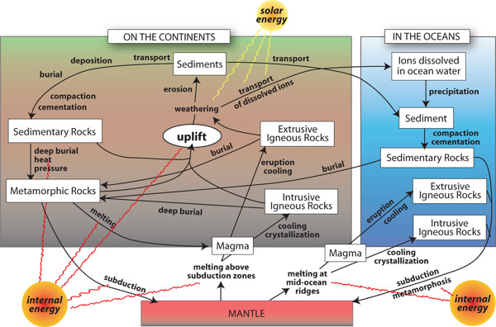
This is a schematic sketch of the rock cycle. In this sketch, boxes represent earth materials and arrows represent the processes that transform those materials. The processes are named in bold next to the arrows. The two major sources of energy for the rock cycle are also shown; the sun provides energy for surface processes such as weathering, erosion, and transport, and the earth's internal heat provides energy for processes like subduction, melting, and metamorphism. The complexity of the diagram reflects a real complexity in the rock cycle. Notice that there are many possibilities at any step along the way.
Rock Cycle Vocabulary
Burial – The process that occurs as sediment is covered over as more layers of sediment accumulate on top (the overburden).
Cementation- The process by which clastic sediment is lithified by precipitation of mineral cement, such as calcite cement, among the grains of the sediment.
Crystallization - The process that occurs when molten magma cools and solidifies into individual crystals/minerals.
Compaction- Tighter packing of sedimentary grains causing weak lithification and a decrease in porosity, usually from the weight of overlying sediment.
Deposition- The settling of materials out of a transporting medium.
Erosion- The processes that loosen sediment and move it from one place to another on Earth's surface. Agents of erosion include water, glaciers, wind, and gravity.
Lithification- The processes by which sediment is converted into sedimentary rock. These processes include cementation and compaction.
Magma- Molten rock, generally a silicate melt with suspended crystals and dissolved gases.
Melting- To go from a solid state to a liquid state.
Metamorphism- Alteration of the minerals and textures of a rock by changes in temperature and pressure, and/or by a gain or loss of chemical components.
Pressure- The force per unit of area exerted upon something, such as on a surface.
Sediment- Material (such as gravel, sand, mud, and lime) that is transported and deposited by wind, water, ice, or gravity; material that is precipitated from solution; deposits of organic origin (such as coal and coral reefs).
Transportation- The processes that carry sediment or other materials away from their point of origin. Transporting media include wind, water, glaciers, and mantle convection currents
Uplift-A structurally high area in the crust, produced by movements that raise the rocks, as in a broad dome or arch.
Weathering- The processes by which rocks are chemically altered or physically broken into fragments as a result of exposure to atmospheric agents and the pressures and temperatures at or near Earth's surface, with little or no transportation of the loosened or altered materials.

