NAME: __________________________ PERIOD: ___ DATE ______________

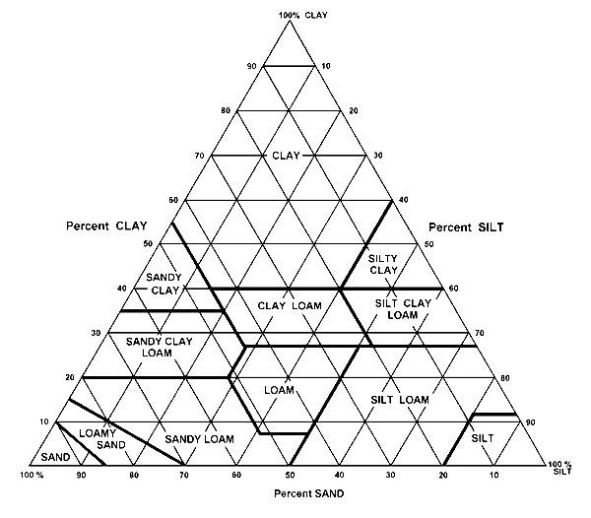THE SOIL TEXTURAL TRIANGLE

Soil Textural Triangle Practice Exercises

% Clay % Sand % Silt Texture Name

a) 30 10 60 Silt Clay Loam

b) 60 30 10

40 40

- 10
Loamy Sand

e) 45 10 45

- 5 35

- 40
10

Name

Soil Texture Worksheet
Date

Directions: Using your soil texture chart and example, determine the following soil textures using the percentages given. REMEMBER: all your percentages should add up to 100!

% Clay % Sand % Silt Soil Texture

example 75 15 15 Clay

- 40
30

50 20

35 50

d) 60 30

e) 45
45

f) 15 50

- 25
45

90 10

- 20 5

j) 35 35

Now for a challenge!:

- 36
Clay Loam

42 Silty Clay

15 Sand

