NAME:__________________________________________ PERIOD: ___ DATE: _____________
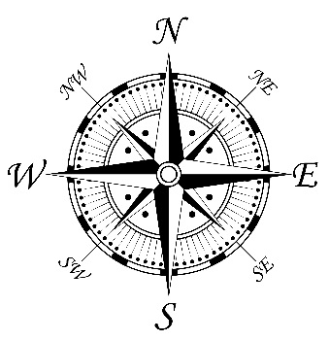
TECTONIC PLATES MOVEMENT
Review your notes on plate tectonics and make sure you know the meaning of the following terms: plates, divergent boundary, convergent boundary, transform boundary, rift valley, and subduction. Use the Tectonic Plate illustration that is located on the back of The Rock Cycle illustration as a reference. The numbers on the map below indicate the rate at which the plates are moving in centimeters per year. Use the compass to indicate direction and the map below to answer the questions.
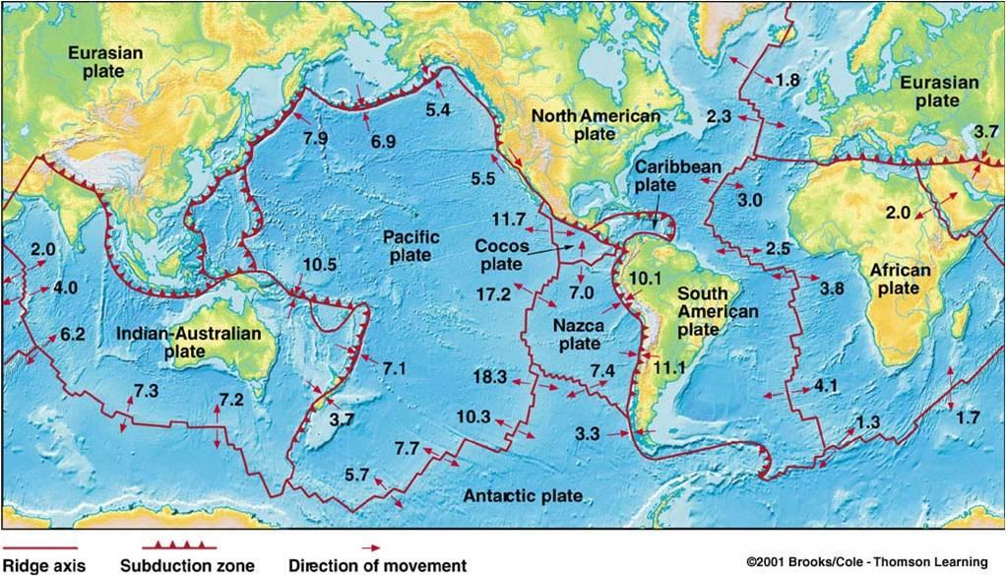
1. In what direction is the Pacific Plate moving?

2. How is the Pacific Plate moving relative to the Antarctic Plate?

3. Explain what is occurring at the boundary between the South American Plate and the Nazca Plate?

4. What would you expect to be the result of the interaction between the South American Plate and Nazca Plate?

5. Describe the relative motion between the North American Plate and the Pacific Plate.

6. In what direction is the Indian-Australian plate moving?

7. What will probable happen to Australia if the plate upon which it sits continues to move the direction shown?

8. Describe the changes taking place in northern East Africa. What will form as a result of the change?

9. What might happen if Africa collides with Europe?

10. Between what two plates is the relative motion the fastest?

11. What feature is common in all oceans? What is the significance of this feature?

12. Would you predict that, over time, the distance between New York and Miami will increase, decrease, or stay the same? Explain your answer.

13. Would you predict that, over time, the distance between New York and Lisbon, a city in southern Europe, will increase, decrease, or stay the same? Explain your answer.

14. Explain why or why not the boundary that form the San Andreas Fault will form a rift valley.

15. What would you expect to be the result of the interaction between the Pacific Plate and Eurasian Plate?

16. Which coast of North America would you expect to have the greater amount of earthquakes, volcanoes and mountains? Why?

17. Which ocean would you expect to have the greatest amount of earthquakes, volcanoes and mountains along its coasts? Why?

18. According to the map what is the probability of either an earthquake or volcano occurring in our region?

